
Risk, Safety & Insurance

Slip, Trip & Fall
Prevention
Tool Kit
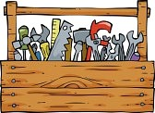

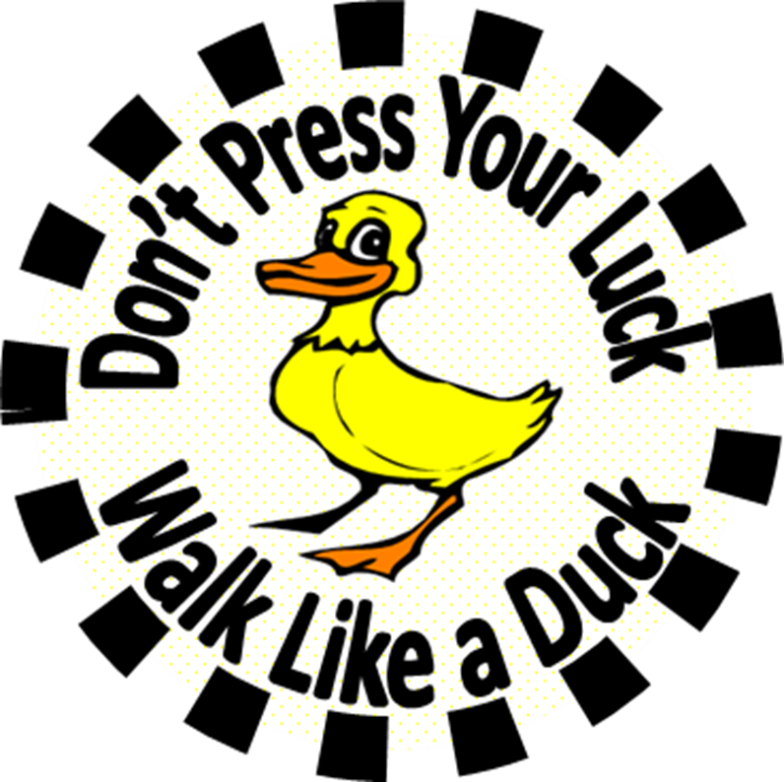
  RISK, SAFETY & INSURANCE | FIVE MINUTE SAFETY HUDDLE  WINTER  SLIP AND FALL PREVENTION  TAKE FIVE! A five-minute safety huddle with your team will help promote a safer environment for everyone!

It is important that each director, manager or supervisor shares these points regularly with the staff. Share them now – and then again after the first snow/ice day.
- Falls are responsible for more open wounds, fractures, and brain injuries than any other causes of injuries. One of the important initiatives to prevent slips, trips and falls is education.

- Does everyone wear proper footwear for weather and workspace conditions? Wear boots in inclement weather and be sure to bring your shoes. All footwear should have soles that grip the walking surface.
- When outdoors, walk like a duck. Take small steps, with feet pointed outward, and keep your weight distributed evenly over each foot. Avoid walking on slippery surfaces, particularly marble, polished wood and tile flooring. These can be slippery due to their smooth texture.
- Areas between vehicles are difficult to de-ice. Hang onto the vehicle for support until you are in a main road or walkway.
- Are there buckets of salt (or other ice-melting agent) at each entry/exit at your location? Remind staff that everyone is responsible for spreading this at entryways.
- Does your site have enough mats at the entry/exit doors?
- Are lighting conditions at peak performance? Report and replace interior and exterior lights that are not working.
- Does everyone know how to enter an incident into Safety First?
- Ask for staff input on how to keep your site free from potential fall hazards. Promote individual ownership of unsafe conditions.
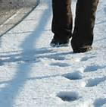  Be nice and de-ice.  When you see icy conditions or packed snow, spread some salt or other melting agent.  During the time you wait for “someone else” to do it, a person could fall. Let’s avoid that—be nice and de-ice! |  |   Be nice and de-ice.  When you see icy conditions or packed snow, spread some salt or other melting agent.  During the time you wait for “someone else” to do it, a person could fall. Let’s avoid that—be nice and de-ice! | Be nice and de-ice.  When you see icy conditions or packed snow, spread some salt or other melting agent.  During the time you wait for “someone else” to do it, a person could fall. Let’s avoid that—be nice and de-ice!

SLIP AND FALL PREVENTION SAFETY TALK
Risk, Safety & Insurance
FIVE-MINUTE TALKING POINTS TO SHARE WITH YOUR CO-WORKERS

- Avoid walking on slippery surfaces, particularly, marble, polished wood and tile flooring. These can be slippery due to their smooth texture.
- Get regular eye exams. If eyewear is needed for certain conditions, purchase and wear the appropriate eyewear. If wearing bi-focal lenses, be aware that objects just below your knee level have a tendency to “disappear” from your line of sight.
- Use mats at entrances to absorb ice, snow and other debris tracked in from outside. Change the mats frequently.
- Keep all floor surfaces in good condition. Repair ripped carpeting, replace damaged floor tiles, and keep naturally abrasive floors clean with appropriate cleaning products.
- Clean up all spills immediately. Use “wet floor” signs while mopping floors and during the drying period. If you see a spill or wet floor area, own it. Ask a co-worker to help either clean the area or at the least, indicate to others to use caution by placing a “wet floor” sign on the wet area.
- Wear proper footwear for weather and workspace conditions. Wear boots in inclement weather and be sure to bring your shoes. If doing physical labor, wear work shoes. All footwear should have soles that grip the walking surface.
- Keep clutter off the floor, out of walkways, stairways, workspaces, and storage areas.
- Keep lighting conditions at peak performance. Report and replace interior and exterior lights that are not working. If needed, take foot-candle readings and increase lighting accordingly.

“To walk on ice, keep your center of gravity over your front leg.”

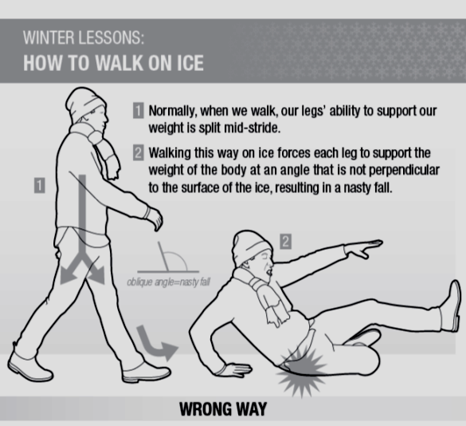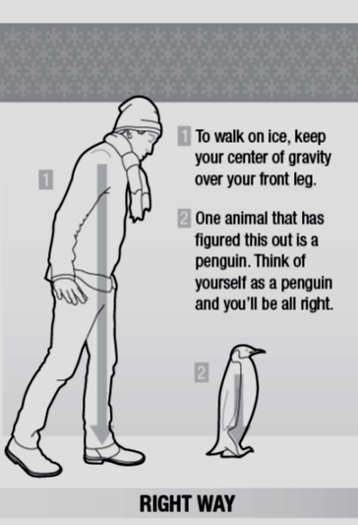

RISK, SAFETY & INSURANCE | FIVE MINUTE SAFETY HUDDLE  SAFETY ON STAIRS  TAKE FIVE! A five-minute safety huddle with your team will help promote a safer environment for everyone!
- Open Access Doors Slowly. When accessing the stairwell, open access doors slowly upon entering or exiting to avoid knocking down anyone on the other side. If you are in a hurry, do NOT fling open the entry door.
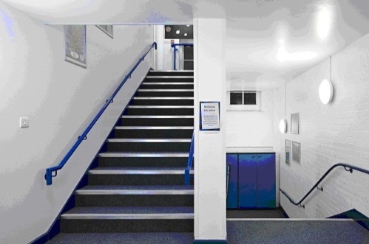
- Stay to the right. Similar to driving a car, stay to your right side when going up or down the stairs. This allows someone to pass you without interfering with your pace.
- Keep your eyes on the stairs. Don’t get distracted by operating your cellphone. It is fine to greet people, but it is more important to keep your eyes on the stairs. If driving, this would be comparable to keeping your eyes on the road.
- Always use the handrail. It is recommended to slightly turn toward the handrail when using the stairs. When falling, most people fall in the direction they are facing. By turning toward the handrail when using the stairs, the momentum from a slip, trip, or fall will help send the person into the rail instead of down the steps.
- Keep stairways clear of all objects. Never use the stairwell as temporary storage.
- Be aware of your footwear. Take extra caution on steps when wearing athletic shoes or high heels.
- Avoid carrying vision-blocking loads. Don't carry so much up and down stairs that you can't see where you are stepping. Also have one hand free to hold onto a handrail. Make several trips with smaller loads.
- If you see a wet spot or spill, own it. Stay with the wet area and alert a co-worker in the area to help isolate the spill. Either clean it up or report it immediately to Environmental Services at your location. Don’t leave the wet area unattended.
- Report any safety issues. If you see any other issues with the stairs, landings, handrails, or doors please report them immediately to your supervisor or Plant Operations.

